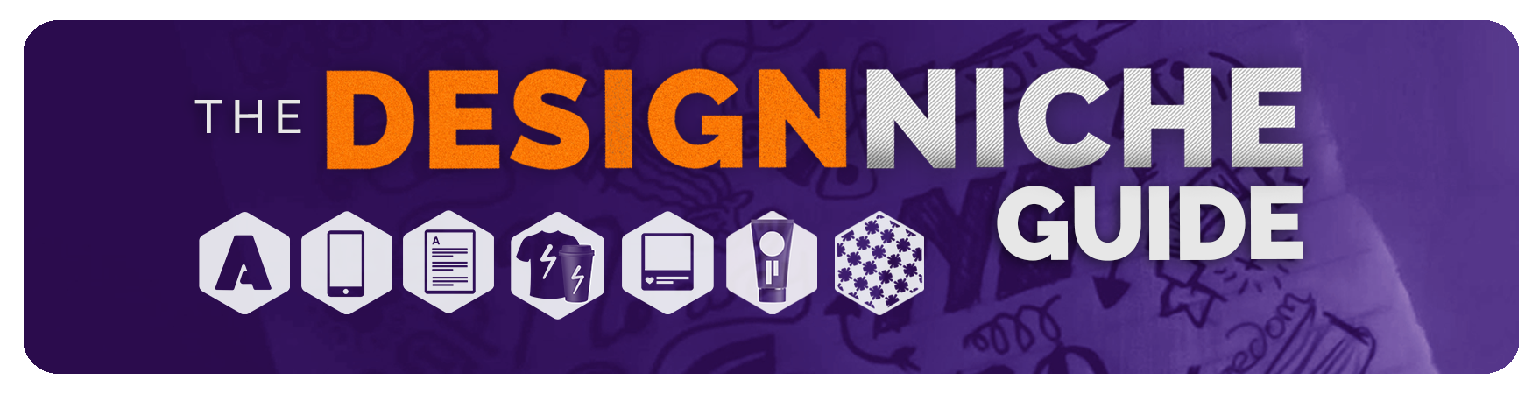   
***Discover Your Top 3!***

**It is now time for your student project.** Work through the answers and find out which ones contained more YES responses. **Put together your list of your top three design niches or focuses from those answers.**   
  
Once you develop your top 3 choices, I want you to**answer a few questions and put together your plan to shift into these three niches.** These questions will be at the end of this guide, after the YES or NO question section. You can also decide to focus on just one Niche for the questions toward the end of the document, the “What’s Next” Questions.   
  
Please feel free to share with me or the class your top three choices and also your game plan for making it happen.

If you are curious about which classes can help get you master any of the design niches covered in this class or learn some of the software required to make it happen, make to it check out below each design niche section. I have provided a page on my website with a helpful video and also discount links to my courses.



**LOGO DESIGN**

If you find yourself answering **YES** to the majority of these questions, then the logo design niche might be one of your top 3 focal niches.

* I can be in a vector program all day and not get bored.
* I love to create new concepts and brainstorm ideas and can do it for long period of time
* I can take vague client statements and turn them into something workable and likable for all parties involved
* I love small details and building and crafting simple graphics like icons and symbols
* I love spending a long time with one project, sometimes creating 30 versions of the same concept to get it just right.

**Programs/Skills to Look into:**Learn a Vector Based Program: Adobe Illustrator or Affinity Designer  
Design Theory: Typography and Color Theory  
Working with Grids  
Mastering the Pen Tool  
Participating in Logo Design Challenges   
 **Class Recommendations**The Logo Design Masterclass   
Graphic Design Masterclass: The NEXT Level (Discount Link)   
Learn The Entire Affinity Suite: Photo, Designer and Publisher

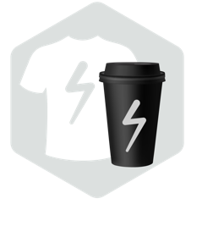

**BRANDING**

If you find yourself answering **YES** to the majority of these questions, then the Brand design niche might be one of your top 3 focal niches.

* You cannot settle on one type of design niche but want to have your hand in all pots
* You love seeing a logo applied to many different items and assets
* You are ok with the idea of working closely with a marketing team
* You are ok with learning a wide Varity of software to hoping from one software to another to complete a task.
* You do not mind hiring help or another designer to complete tasks in areas you may not be proficient in to complete a branding project. You like working as part of a team and not just a solo designer

**Programs/Skills to Look into:**Adobe Creative Suite: Photoshop, Illustrator, InDesign or similar programs (Affinity Designer)  
Design Theory: Color Theory and Phycology, Layout, Photo Editing  
Marketing Theory: Brand Development, Marketing, Marketing Research, Target Demographics  
Learn proper brand presentations   
Learn how to adapt to all types of design situations with a brand (both print and web)

**Class Recommendations**

[Graphic Design Mastery: The FULL Branding & Design Process](https://lindsaymarsh.myportfolio.com/udemy-discount-coupons)  
[The Digital Design Masterclass](https://lindsaymarsh.myportfolio.com/udemy-discount-coupons)



**PRINT & EDITORIAL DESIGN**

If you find yourself answering **YES** to the majority of these questions, then the Print Design & Editorial niche might be one of your top 3 focal niches.

* I love designing magazine layouts and spreads
* I love the printing process and love to get quotes and find the right varnish, paper or ink color for my clients printed projects
* I am ok with the occasional tedious job, that may require me to sit down for several days and work through 30-40-page layouts.
* I love metallic inks; bright Pantone colors and I love feeling all the different paper textures I can print on
* I am wanting to learn great layout theory and can balance out photos, type and design elements to create a solid design.
* I love working with large blocks of type and copy and finding clever ways to present otherwise boring information

**Programs/Skills to Look into:**Single Page Layout Program: Adobe Illustrator or Affinity Designer

Multiple Page Layout Program: Adobe InDesign

Design Theory: Layout and Typography Theory   
How to work with printers and the printing process: CMYK printing, Pantone and Spot Colors, UV Finishes, Paper Options, Understanding Bleed and Ad Specs etc.   
  
**Class Recommendations**  
[Master Graphic Design Through Projects: Beginner to Advanced](https://lindsaymarsh.myportfolio.com/udemy-discount-coupons)

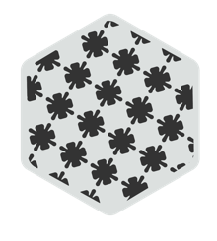  
**PATTERN DESIGN & ILLUSTRATION**

If you find yourself answering **YES** to the majority of these questions, then the Pattern Design & Illustration niche might be one of your top 3 focal niches.

* I am attracted to patterns and illustrations seen on products in stores and wish to create patterns and illustrations of my own
* I enjoy the art of drawing and sketching
* I want to work with a wide Varity of art mediums like watercolor for example
* I love illustration
* I am a highly creative person and prefer to feel and touch what I design
* I am a self-starter and may want to create my own product line or create illustrative design assets and patterns one day.

**Programs/Skills to Look into:**Vector Based Program for Pattern Design: Adobe Illustrator or Affinity Designer   
How to create seamless patterns  
Illustration techniques  
Digital Sketching App: Procreate or Equivalent

Sketching, drawing, watercolor and other mixed media art  
How to work with printers and the printing process: CMYK printing, Pantone and Spot Colors, UV Finishes, Paper Options, Understanding Bleed and Ad Specs etc.



**PACKAGE DESIGN**

If you find yourself answering **YES** to the majority of these questions, then the Package Design niche might be one of your top 3 focal niches.

* You have an ability to think in 3-D or apply a flat design to a 3-D product in your mind as you design
* You have a desire of feeling and seeing your final design in your hands or on a store shelf
* You admire great package design when you are shopping
* You do not mind spending up to one month working on one project.
* You do not mind working with sometimes complex printer templates to apply your finished design to

**Programs/Skills to Look into:**Vector based program: Adobe Illustrator or Affinity Designer

Understanding working with printing templates  
How to work with printers and the printing process: CMYK printing, Pantone and Spot Colors, UV Finishes, Paper Options, Understanding Bleed and Ad Specs etc.

3D Mock-up program to test your package designs with – Adobe Dimensions

**Class Recommendations**

[Graphic Design Mastery: The FULL Branding & Design Process   
Graphic Design Masterclass: The NEXT Level](https://lindsaymarsh.myportfolio.com/udemy-discount-coupons)



**UX/UI DESIGN**

If you find yourself answering **YES** to the majority of these questions, then the UX/UI Design niche might be one of your top 3 focal niches.

* You like surrounding yourself with data and ideas and picking out themes and finding answers through this data to help you with your project
* You enjoy the creative visual design process, but you can switch between both creative and research focused tasks with any issues.
* You love to brainstorm ideas to find the right user flows for apps, programs and websites
* You are fast at research and quick to put together and finish projects
* You enjoy design for digital products and do not mind the tedious task of mapping out all possible directions a user can go in.
* You can work well with a developer/coder making your digital designs a reality

**Programs/Skills to Look into:**Design Theory: Typography, layout and UX Design theory

A Wireframing Tool: Adobe XD, Sketch, Figma  
Learn how to create low and high fidelity wireframes  
Learn how to create user personas and user flows to create website or app flows that work well for a user  
Learn how to research and gather, interpret various user data  
Learn how to test your prototypes and make improvements to your design and user flow

**Class Recommendations**[User Experience Design - Learn the UX UI Process & Adobe XD](https://lindsaymarsh.myportfolio.com/udemy-discount-coupons)



**DIGITAL DESIGN & SOCIAL MEDIA**

If you find yourself answering **YES** to the majority of these questions, then the Digital Design & Social Media niche might be one of your top 3 focal niches.

* I love a fast pace work life where I may switch client projects several times an hour or day.
* I love puzzles and finding out ways to fit larger designs into smaller spaces
* I do not mind creating 20 graphics of the same ad campaign.
* I love photo editing, all aspects of it and do not mind doing photo manipulations and editing projects that clients requires that may be brand new to me.
* I do not mind understanding and learning the online paid ad creation process for a wide Variety of social media platforms like Facebook, Instagram etc.

**Programs/Skills to Look into:**Raster program: Adobe Photoshop or Equivalent

Photo Editing and Manipulation Skills

Understanding how paid ads work, sizing, efficiency on Facebook, Instagram, etc.

Learning how to create and size display ads (static ads on websites etc.)

Quick Layout Program like Canva to speed up your workflow  
**Skills:** Learn how to create branded campings across multiple digital channels  
(Optional) Learn some animation techniques to make your ads move (as simple as learning GIFs in Photoshop)  
To take a step further, you can learn wordpress, Squarespace or webflow to create basic landing pages and websites to complete their digital campaigns

**Class Recommendations**[The Digital Design Masterclass for Graphic Designers](https://lindsaymarsh.myportfolio.com/udemy-discount-coupons)

**NEXT STEPS:** Now What?   
Let’s put together your action or game plan to start learning and developing the right skills to master your top three focal niches to eventually develop your specialty.

Answer the following questions in as much detail as you feel comfortable.   
  
**Is there any new software I need to learn? If so which ones? Create your list with the top in the list being first priority.**

* Vector Program (Illustrator, Affinity Designer)
* Multi-page editor and layout program (InDesign)
* Photo Editing Program (Photoshop etc.)
* Design Tools and layout programs (Canva etc.)
* Wireframing Tools (Adobe Xd, Sketch etc.)
* Sketching and Drawing Apps (Procreate etc.)
* Art Mediums? (Drawing, sketching, painting, watercolor etc.)
* Website Creation Apps (Webflow, Squarespace, Wordpress, Wix etc.)

**Is there any design theory I need to brush up on? If so, what?   
Color Theory**

* Typography Theory
* Layout Theory
* Photography and Photo Editing
* Sketching, Drawing
* Illustration
* UX/UI Theory

**I may need to do a few practice projects first before taking on client work, what will be my first practice project in this niche?**   
Example: Social Media Ad Campaign, Web Design Layout, Logo Design. Feel free to be as detailed as you like about this project. An example of this can be seen in my student project in the class.

Project 1____________________________  
  
Project 2____________________________

Project 3____________________________

**Fears, Hopes and Dreams about shifting to a new design focus/niche?**

**Fears?  
(**Example: digital design is new to me, and I fear I will not be able to learn all the software involved)

**Hopes?  
(**Example: I hope to switch int this design focus as my main income someday)

**Dreams?**

**(**Example: I dream that this will change my life for the better and I can ENJOY my job)

**Extra questions to think about during this process**

**Interested in going freelance? Or staying in-house at a company with this design focus?**

**What is your timeline in learning the new tools and skills required for some of these focuses?   
(**Example: Learn Wordpress by next April etc.) **What are some general action items for me so I can start moving forward?**Take a class, connect with a mentor in a similar space, join social media groups of a similar focus, downloading the software I need to learn, buying a few books in this focus, creating some practice projects?

I have provided a page on my website with a helpful video and also discount links to my courses if any of them interested you above. <https://lindsaymarsh.myportfolio.com/udemy-discount-coupons>